***What is AOP and AOP terms?***

* Separating the logic and provides modularity
* Point-Cut Which methods to intercept?
* Advice – When to intercept method?
  + Before, After, AfterReturning, Around
* Aspect – Combination of point cut and advice
* Join point – execution instance of an advice

***@Before advice***

1. Create an aspectConfig class
2. Inside create a logger
3. Use @Before(value = “execution(*com.example.controller.*.*)”) in a method that use the logger info
4. Mark the class as @Aspect and Configuration

***@Before advice with method parameter***

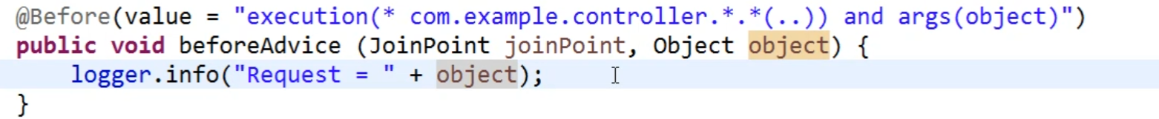

***@After advice***

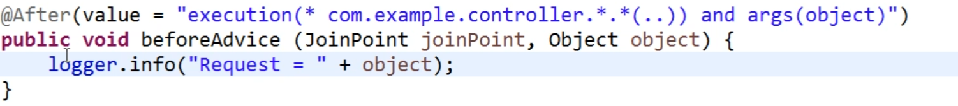

**@AfterReturning Advice**

***@Around Advice***

